Class diagram

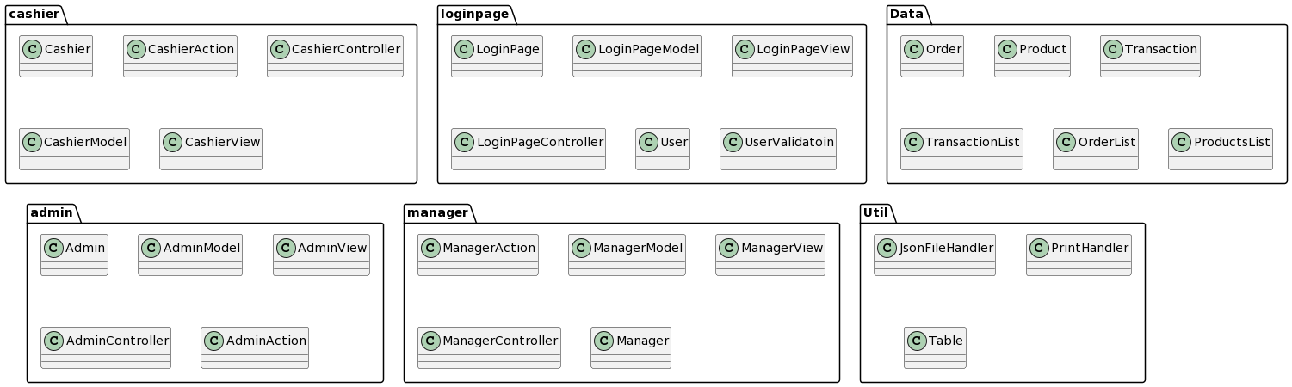

Class diagram with functionalities

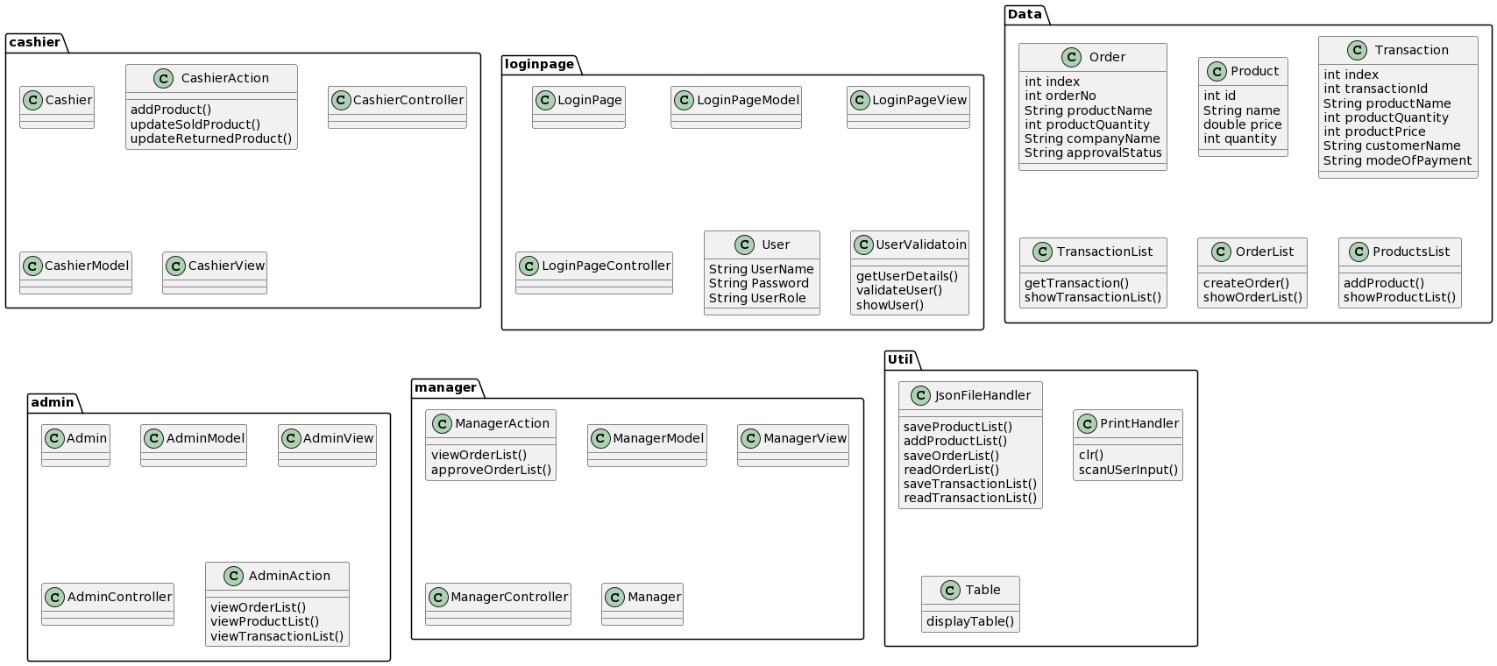

Link

//www.plantuml.com/plantuml/dpng/PPB1QiCm38RlVOeyIal76ADbFRIzQxR9n1Ivs0exZBpxQ8AcA3xga_NxG_Q-2XGP1zez87n3dxe0zGjJ-Tq5WbgxevQJ1uSWcBd1nynICj4yqVdUEST4pSGTqyyJJly6b7la1_H97KvFS9d1j4KMwhd6Rh3vMVDMjzKT22D8HlPcBo2WKXybhiSk9SSnY85h0QwWMshX2QkUrZH5Bh4gDGs80x9w79PYMfUs56Ewa1Lgbg4DUroxT026tlx5UIdjfCCguAagEDX8MCiBt0H9Rt-lcL-HqXjm9FyCoDBGAtnIMjBsYUCuq1y0